Three Variance Reduction Techniques Implementation

1. **Importance Sampling (cosine-weighted)**

Importance Sampling is a technique used to reduce the variance in Monte Carlo integration by sampling more frequently in regions that contribute more to the final result.

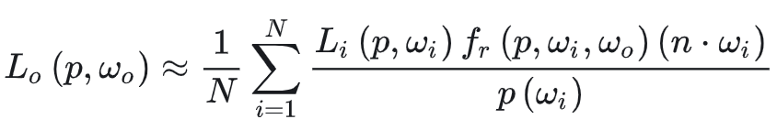

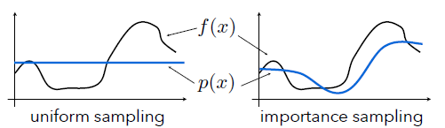

截屏2023-12-18 14.29.11

We need to let probability density function of sampling be proportional to the integrand function. In this case, I choose cosine-weighted term.

Therefore, we can get that

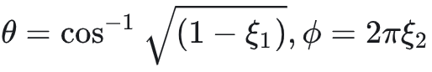

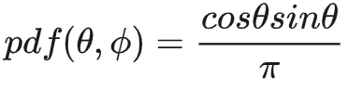

Sampling Spherical Coordinates: sample2 is used to obtain a well-distributed 2D vector in the range [0,1). These values are then converted into spherical coordinates theta and phi.

Local Frame and Importance Sampling: makeLocalFrame is called to create a local coordinate frame around the normal. The local frame is used to convert the spherical coordinates into a 3D direction vector (importanceSampledDirection), ensuring that the sampled directions are aligned with the surface.

Probability Calculation: The probability of sampling the given direction is calculated. In this case, cos(theta) / M_PI is used as the probability density function (PDF). The use of cos(theta) ensures that the directions are sampled with a cosine-weighted distribution, which is important for diffuse surfaces.

Setting Result: The sampled direction and its associated probability are set in the result structure.

The below figure shows the result: the bottom image (with importance sampling) converge much further than the top image (no variance reduction, uniform random sampling). Both images are rendered at resolution 256×128.

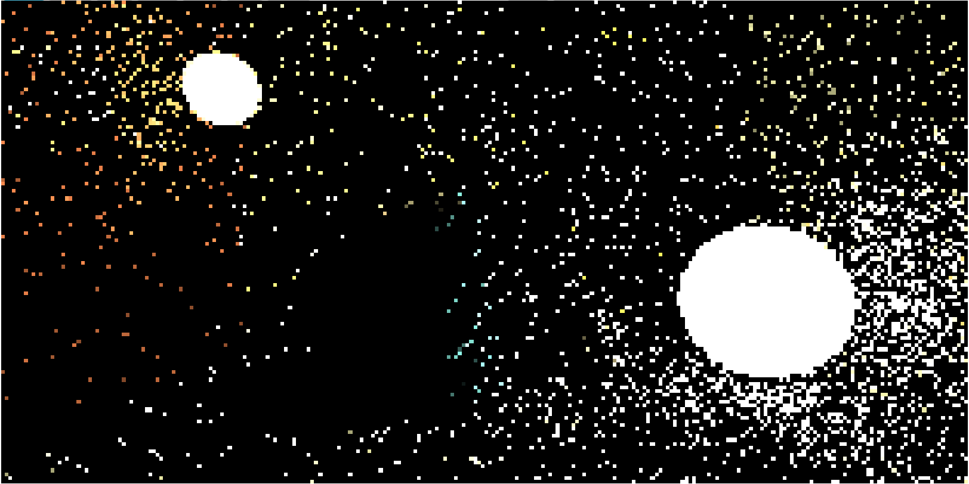

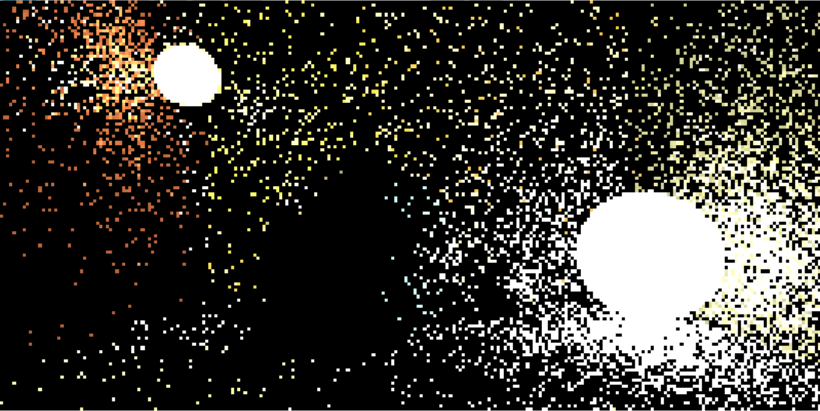

The below figure shows the result: the bottom image (with Quasi-Monte Carlo sampling) converge much further than the top image (no variance reduction, uniform random sampling). Both images are rendered at resolution 256×128.



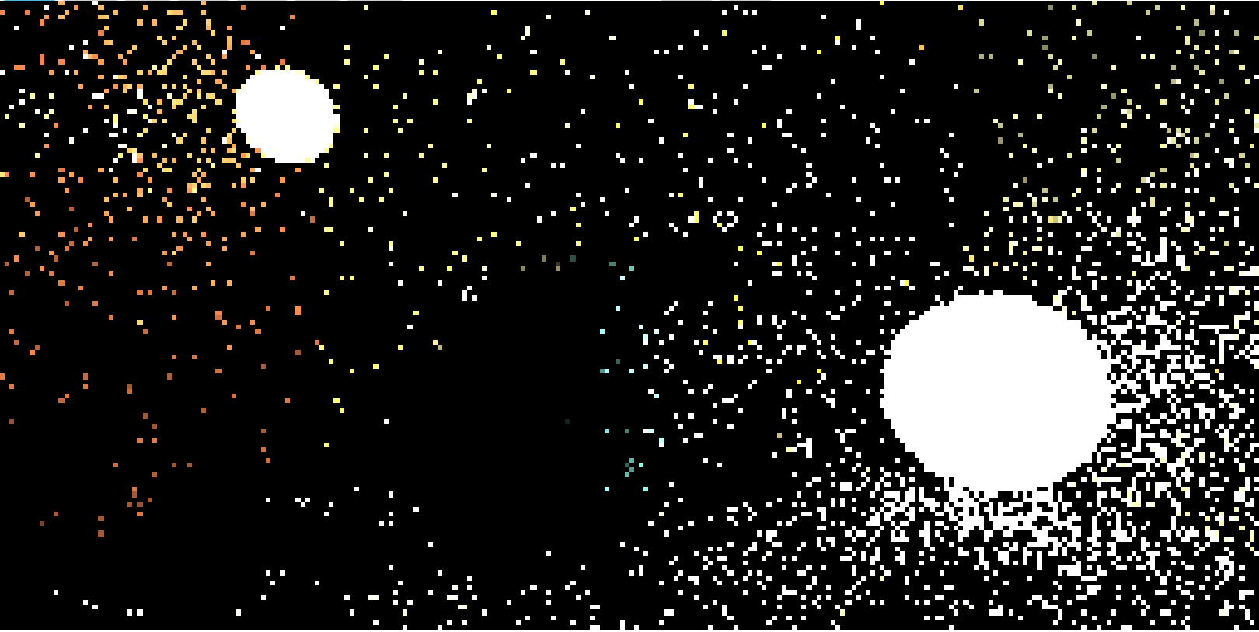

The below figure shows the result: the bottom image (with next event estimation) converge much further than the top image (no variance reduction, uniform random sampling). Both images are rendered at resolution 256×128.



